INTEL MICROPROCESSORS 8086/8088

SALIENT FEATURES:
8086 is the first 16-bit microprocessor from INTEL, released in the year 1978 . It is a 40 pin DIP chip based on N-channel, depletion load silicon gate technology(HMOS). The term 16 bit means that its ALU,its internal registers and most of the instructions are designed to work with 16 bit binary words.8086 is available at different clock speeds Viz, 5 M.Hz(8086);8M.Hz(8086-2) and 10(8086-1) M.Hz .8086 microprocessor has a 16-bit data bus and 20-bit address bus. So, it can address any one of 2²⁰ =1048576=1 mega byte memory locations. INTEL 8088 has the same ALU ,same registers and same instruction set as the 8086.But the only difference is 8088 has only 8-bit data bus and 20-bit address bus. Hence the 8088 can only read/write/ports of only 8-bit data at a time .The 8088 was used as the CPU in the original IBM personal computers [ IBMPC/XT] .The 8086 microprocessor can work in two modes of operations .They are Minimum mode and Maximum mode. In the minimum mode of operation the microprocessor do not associate with any co-processors and can not be used for multiprocessor systems. But in the maximum mode the 8086 can work in multi-processor or co-processor configuration. This minimum or maximum operations are decided by the pin MN/ MX’(Active low). When this pin is high 8086 operates in minimum mode otherwise it operates in Maximium mode.It supports memory segmentation and instruction queue.

Differences between 8086 and 8088 Microprocessors :

Though the architecture and instruction set of both 8086 and 8088 processors are same, still we find certain differences between them They are
(i) 8086 has 16-bit data bus lines whereas 8088 has 8-data lines.
(ii) 8086 is available in three clock speeds namely 5 M.Hz,8M.Hz(8086-2) and 10 M.Hz
(8086-1) whereas 8088 is available is only available only in two speeds namely
5M.Hz and 8M.Hz
(iii) The memory address space of 8086 is organized as two 512kB banks whereas 8088
memory space is implemented as a single 1MX 8 memory bank.
(iv) 8086 has a 6-byte instruction queue whereas 8088 has a 4 byte instruction queue .
The reason for this is that 8088 can fetch only one byte at a time.
(v) In 8086 the memory control pin ( M/ IO’) signal is complement of the 8088
equivalent signal(IO/M’)
(vi) The 8086 has BHE’(Bank high enable) whereas 8088 has SSO status signal .
(vii).The byte and word data operations of 8086 are different from 8088.
(viii) 8086 can read or write either 8-bit or 16-bit word at a time ,whereas 8088 can read
only 8-bit data at a time.
(ix) The I/O voltage levels for 8086 are , Vol is measured at 2.5mA and for 8088 it is
measured at 2.0mA.
(x) 8086 draws a maximum supply current of 360 mA and the 8088 draws a maximum
of 340 mA.
8086 PIN DIAGRAM – PIN DESCRIPTION
Intel 8086 is a 16-bit HMOS microprocessor. It is available in 40 pin DIP chip. It uses a 5V d.c. supply for its operation. The 8086 uses 20-line address bus. It uses a 16-line data bus. The 20 lines of the address bus operate in multiplexed mode. The 16-low order address bus lines are multiplexed with data and 4 high-order address bus lines are multiplexed with status signals. The pin diagram of Intel 8086 is shown in Fig.4.

AD₀-AD₁₅ (Bidirectional) : Address/Data bus. These are low order address bus. They are multiplexed with data. When AD lines are used to transmit memory address the symbol A is used instead of AD, for example A0-A15. When data are transmitted over AD lines the symbol D is used in place of AD, for example D₀-D₇, D₈-D₁₅ or D₀-D₁₅.

A₁₆-A₁₉ (Output) : High order address bus. These are multiplexed with status signals.
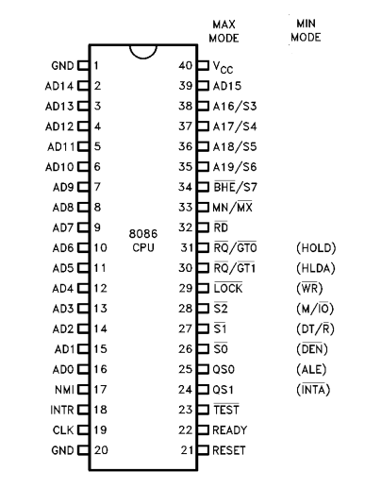
Fig.4. Pin Diagram of 8086 Processor

A₁₆/S₃, A₁₇/S₄, A₁₈/S₅, A₁₉/S₆ : The specified address lines are multiplexed with corresponding status signals.

BHE (Active Low)/S₇ (Output) : Bus High Enable/Status. During T1 it is low. It is used to enable data onto the most significant half of data bus, D8-D15. 8-bit device connected to upper half of the data bus use BHE (Active Low) signal. It is multiplexed with status signal S7. S7 signal is available during T2, T3 and T4.

RD (Read) (Active Low) : The signal is used for read operation. It is an output signal. It is active when low.
READY : This is the acknowledgement from the slow device or memory that they have completed the data transfer. The signal made available by the devices is synchronized by the 8284A clock generator to provide ready input to the 8086. the signal is active high.
INTR-Interrupt Request : This is a triggered input. This is sampled during the last clock cycles of each instruction to determine the availability of the request. If any interrupt request is pending, the processor enters the interrupt acknowledge cycle. This can be internally masked by resulting the interrupt enable flag. This signal is active high and internally synchronized.
NMI (Input) –NON-MASKABLE INTERRUPT : It is an edge triggered input which causes a type 2 interrupt. A subroutine is vectored to via an interrupt vector lookup table located in system memory. NMI is not maskable internally by software. A transition from LOW to HIGH initiates the interrupt at the end of the current instruction. This input is internally synchronized.
INTA: INTA: Interrupt acknowledge. It is active LOW during T ₂ ,T ₃ and T _{w} of each interrupt acknowledge cycle.
MN/ MX MINIMUM / MAXIMUM :This pin signal indicates what mode the processor is to operate in.
RQ/GT RQ/GT0 : REQUEST/GRANT: These pins are used by other local bus masters to force the processor to release the local bus at the end of the processor's current bus cycle. Each pin is bidirectional with RQ/GT having higher priority than RQ /GT₁.
LOCK: Its an active low pin. It indicates that other system bus masters are not to allowed to gain control of the system bus while LOCK is active LOW. The LOCK signal remains active until the completion of the next instruction.
TEST : This input is examined by a ‘WAIT’ instruction. If the TEST pin goes low, execution will continue, else the processor remains in an idle state. The input is synchronized internally during each clock cycle on leading edge of clock.
CLK- Clock Input : The clock input provides the basic timing for processor operation and bus control activity. Its an asymmetric square wave with 33% duty cycle.
RESET (Input) : RESET: causes the processor to immediately terminate its present activity. The signal must be active HIGH for at least four clock cycles.

Vcc – Power Supply ( +5V D.C.)

GND – Ground
QS₁,QS₀ (Queue Status) These signals indicate the status of the internal 8086 instruction queue according to the table shown below

QS_{I} | QS₀ | Status
0 (LOW)  0  1 (HIGH)  1 | 0  1  0  1 | No Operation  First Byte of Op Code from Queue  Empty the Queue  Subsequent Byte from Queue

DT/R : DATA TRANSMIT/RECEIVE: This pin is needed in minimum system that desires to use an 8286/8287 data bus transceiver. It is used to control the direction of data flow through the transceiver.

DEN: DATA ENABLE .This pin is provided as an output enable for the 8286/8287 in a minimum system which uses the transceiver. DEN is active LOW during each memory and I/O access and for INTA cycles.

HOLD/HOLDA : HOLD indicates that another master is requesting a local bus .This is an active HIGH. The processor receiving the ``hold'' request will issue HLDA (HIGH) as an acknowledgement in the middle of a T ₄ or T ₁ clock cycle.

MEMORY ORGANIZATION :

The 8086 processor provides a 20-bit address toaccess any location of the 1 MB memory space. The memory is organized as a linear array of 1 million bytes, addressed as 00000(H) to FFFFF(H). The memory is logically divided into code, data, extra data, and stack segments of up to 64K bytes each . Physically, the memory is organized as a high bank (D15 - D8) and a low bank (D7 –D0) of 512 K 8-bitbytes addressed in parallel by the processor's address lines A19 -A1. Byte data with even addresses is transferred on the D7 – D0 bus lines while odd addressed byte data (A0 HIGH) is transferred on the D15-D8 bus lines. The processor provides two enable signals, BHE and A0 , to selectively allow reading from or writing into either an odd byte location, even byte location, or both. The instruction stream is fetched from memory as words and is addressed internally by the processor to the byte level as necessary.

INTERRUPTS :
An interrupt to the microprocessor is defined as that which disturbs the normal execution of a program . Broadly the interrupts are divided into two types. They are external hardware Interrupts and internal (Software) Interrupts . The hardware interrupts are classified as non-maskable and maskable interrupts. The hardware interrupt is caused by any peripheral device by sending a signal through a specified pin to the microprocessor. Whereas internal interrupts are initiated by the state of the CPU (e.g. divide by zero error) or by an instruction. So, the software interrupt is one which interrupts the normal execution of a program of the microprocessor. The 8086 has two hardware interrupt pins namely NMI and INTR.In the two ,the NMI is a non-maskable interrupt and the INTR interrupt request is a maskable interrupt which has lower proirity .The third pin associated with the hardware interrupts are the INTA called interrupt acknowledge.
NMI : The processor provides a single non-maskable interrupt pin (NMI) which has higher priority than the maskable interrupt request pin (INTR). A typical use would be to activate a power failure routine. The NMI is edge-triggered on a LOW-to-HIGH transition. The activation of this pin causes a type 2 interrupt.
INTR: The 8086 provides a single interrupt request input (INTR) which can be masked internally by software with the resetting of the interrupt enable FLAG status bit. The interrupt request signal is level triggered. It is internally synchronized during each clock
cycle on the high-going edge of CLK. To be responded to, INTR must be present (HIGH) during the clock period preceding the end of the current instruction or the end of a whole move for a block type instruction.
Software Interrupts: Coming to the software interrupts , 8086 can generate 256 interrupt types through the instruction INT n .Any of the 256 interrupt types can be generated by specifying the interrupt type after INT instruction . For example INT 33 will cause type 33 interrupt.
I k Bytes of memory from 00000H to 003FF H is set aside to store the starting address of the Interrupt service sub-routine(ISS) programs in an 8086 based systems. To store the starting address of the each ISS , four bytes of memory space is required.Two bytes are for storing CS value and two bytes for IP value. The starting address of an ISS stored in 1kB of memory space is called Interrupt pointer or Interrupt vector.The 1kB memory space acts as a table and it is called Interrupt Vector Table(IVT).
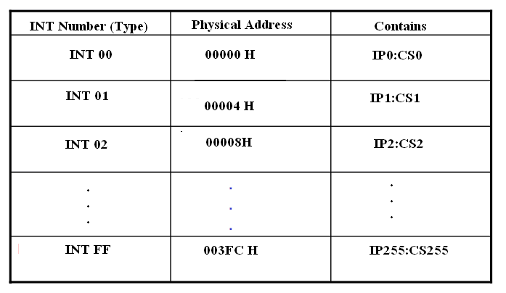

The 256 interrupt pointers have been numbered from 0 to 255.The number given to an interrupt pointer denotes the type of the interrupt. For example Type0,Type1,Type2 etc…The starting address of the ISS for type0 interrupt is 000000H.For type1 interrupt is 00004H similarly for type2 is 00008H ……In the IVT the first five pointers are dedicated interrupt pointers. They are :
TYPE 0 Interrupt corresponds to divide by zero situation
TYPE 1 Interrupt corresponds to Single step execution during the debugging of a program.
TYPE 2 Interrupts to non-maskable NMI interrupt.
TYPE 3 :Interrupt corresponds to break point interrupt.
TYPE 4 Interrupt corresponds to Overflow interrupt.
The Interrupts from Type 5 to Type 31 are reserved for other advanced microprocessors,and from 32 to Type 255 are available for hardware and software interrupts.
Differences between CALL and INT : In fact both the instructions CALL and INT n
will interrupt the execution of the main program. But there are certain differences
between their functioning. They are given below in the table.

S.No | CALL Instruction | INTn instruction
1 | Upon the execution ,the control will jump to any one of the 1 MB of memory locations . | Upon execution the control will jump to a fixed location in the vector table.
2 | The user can insert in the sequence of instructions of a program | Can occur at any time activated by hardware
3 | Once initiated it cannot be masked | Can be masked
4 | When initiated ,it stores the CS:IP of the next instruction on the stack | When initiated ,it stores the CS:IP of the next instruction and also the flag register on the stack.
5 | The last instruction of the subroutine will be RET | The last instruction of the ISS will be IRET

ASSEMBLY LANGUAGE DEVELOPMENT TOOLS:
To develop an assembly language program we need certain program development tools .The various development tools required for 8086 programming are explained below.
1. Editor : An Editor is a program which allows us to create a file containing the assembly language statements for the program. Examples of some editors are PC write Wordstar. As we type the program the editor stores the ACSII codes for the letters and numbers in successive RAM locations. If any typing mistake is done editor will alert us to correct it. If we leave out a program statement an editor will let you move everything down and insert a line. After typing all the program we have to save the program for a hard disk. This we call it as source file. The next step is to process the source file with an assembler. While using TASM or MASM we should give a file name and extension .ASM.
Ex: Sample. asm
2.Assembler : An Assembler is used to translate the assembly language mnemonics into machine language( i.e binary codes). When you run the assembler it reads the source file of your program from where you have saved it. The assembler generates two files . The first file is the Object file with the extension .OBJ. The object file consists of the binary codes for the instructions and information about the addresses of the instructions. After further processing, the contents of the file will be loaded in to memory and run. The second file is the assembler list file with the extension .LST.
3. Linker : A linker is a program used to connect several object files into one large object file. While writing large programs it is better to divide the large program into smaller modules. Each module can be individually written, tested and debugged. Then all the object modules are linked together to form one, functioning program. These object modules can also be kept in library file and linked into other programs as needed. A linker produces a link file which contains the binary codes for all the combined modules. The linker also produces a link map file which contains the address information about the linked files. The linkers which come with TASM or MASM assemblers produce link files with the .EXE extension.
4.Locator : A locator is a program used to assign the specific addresses of where the segments of object code are to be loaded into memory. A locator program called EXE2BIN comes with the IBM PC Disk Operating System (DOS). EXE2BIN converts a .EXE file to a .BIN file which has physical addresses.
5. Debugger: A debugger is a program which allows to load your object code program into system memory, execute the program, and troubleshoot or debug it. The debugger allows to look into the contents of registers and memory locations after the program runs. We can also change the contents of registers and memory locations and rerun the program. Some debuggers allows to stop the program after each instruction so that you can check or alter memory and register contents. This is called single step debug. A debugger also allows to set a breakpoint at any point in the program. If we insert a break point , the debugger will run the program up to the instruction where the breakpoint is put and then stop the execution.
6. Emulator: An emulator is a mixture of hard ware and software. It is usually used to test and debug the hardware and software of an external system such as the prototype of a microprocessor based instrument.

-----------------x------------------

